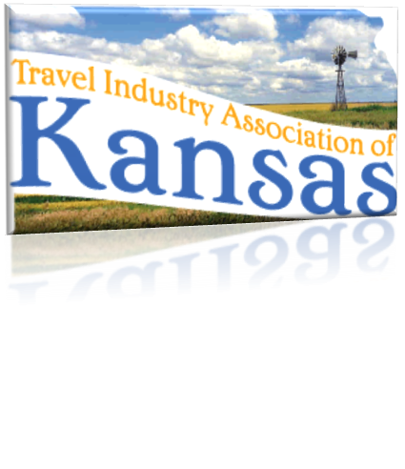
825 S Kansas, Suite 502 • Topeka, Kansas 66612 • 785.233.9465 • www.tiak.org
Travel Industry Association of Kansas
marlee@brightcarpenter.com • natalie@brightcarpenter.com

March 21, 2013
Written Testimony in support of HB 2402
Before the House Agriculture and Natural Resources Committee
By Sally Fuller, President

Chairman Schwartz and members of the Committee:
Thank you for the opportunity to present testimony in favor of HB 2402, which proposes to designate the last Saturday in July of each year as the National Day of the Cowboy in Kansas. The Travel Industry Association of Kansas (TIAK) is the unified voice that speaks on behalf of the travel industry in the state of Kansas. Our organization has over 160 members that represent and promote communities all over Kansas. As the leading advocate for Kansas tourism, TIAK welcomes the opportunity to honor one of the greatest influences on our state’s history.
Cowboy heritage is an important aspect of our state’s history and a significant attraction for many travelers to Kansas. Cowboy events are celebrated frequently across the state attracting tourist to Kansas and bringing our state’s history alive in the minds of travelers. The members of TIAK work daily to attract visitors to Kansas. As such, we believe HB 2402 fits well with the goals of Kansas tourism and if passed will be a useful tool for our state’s national and international marketing plans.
Passage of HB 2402 will bring yet another aspect of our states heritage to the forefront and the members TIAK encourage your support of Kansas heritage and HB 2402.

