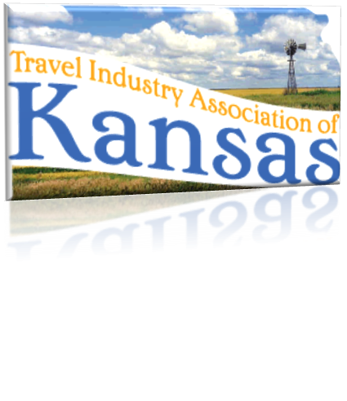
825 S Kansas, Suite 502 • Topeka, Kansas 66612 • 785.233.9465 • www.tiak.org
Travel Industry Association of Kansas
marlee@brightcarpenter.com • natalie@brightcarpenter.com

Testimony in Opposition to HB 2567
Presented to the House Judiciary Committee
by Karen Hibbard
February 19, 2014

Chairman Kinzer and honorable committee members,
I am appearing on behalf of the Travel Industry Association of Kansas (TIAK), which is the unified voice speaking on behalf of the travel industry in the state of Kansas. Our organization has over 150 members representing and promoting communities all over Kansas. I am serving President of TIAK this year. I am also the Director of the Manhattan Convention and Visitors Bureau. Thank you for the opportunity to appear before you to express the concerns the Travel Industry has with HB 2567.
As introduced, HB 2567 proposes to designate any nonprofit organizations supported in whole or in part by public funds, which are engaged in economic development, tourism or general marketing activities for the state or any political or taxing subdivision, a public agency and deems any recorded information, regardless of form or characteristics, by the nonprofit a public record. Some will tell you that this bill is good public policy and that it will promote government efficiency, however, if passed this bill would be devastating to the “open for business” policy we have adopted in Kansas.
While proponents of this bill argue it as a way to promote transparency and open records, the true impact of the bill is that it will have significant costs not only in the amount of time and money it will take for the non-profit organizations to administer, but will put those charged with recruiting businesses and events to Kansas at a significant competitive disadvantage.

Specifically, HB 2567 would require our TIAK members to openly share their strategies for attracting major conferences and events to Kansas. Cities that we compete with to secure local, regional and national conferences would have access to see exactly who we are targeting, how we are targeting them and any commitments that we have made to secure a group. In addition, it would force exposure of the trade secrets of our private sector partners, which very likely would discourage doing business in Kansas.

Consider if a city is competing with Oklahoma City, who is not subject to an open records act and are not required to post their ledgers publically. Passage of HB 2567 would have Kansas communities handing over their game plan to Oklahoma City who could then pursue a conference that may not already be on their radar screen. They would be able to determine our meeting planners as well as the strategy targeted for future opportunities. The competition would also learn how we are allocating our resources on specific tactics such as ad buys, sales blitz’s and digital campaigns. All of these competitive advantages would be lost and significantly hurt the travel industries ability to attract meetings, tradeshows and/or conferences.

The members of TIAK support transparency and open government. Our industry complies with independent audits, and files IRS non-profit Form 990s that provide information on our respective organization's mission, programs, and finances, which are of public record. Our members have boards compromised of both public and private sector business and community leaders present who receive financial and activity reports frequently. TIAK members support open records, but not to the extent that it disadvantages our efforts to grow our state’s economy. Thank you for the opportunity to appear before you. I will stand for questions.

